Ideation Phase
Empathize & Discover
Date | 16 February 2026
Team ID | LTVIP2026TMIDS88973
Project Name | Civil Engineering Insight Studio
Maximum Marks | 4 Marks

Empathy Map Canvas:
The empathy map for Explore with AI by Civil Engineering Insight Studio focuses on understanding travelers’ real needs, emotions, and behaviors to create meaningful and personalized travel experiences. Travelers often express a desire for trips that match their interests, budget, and time while avoiding the stress of extensive research and planning. They think about whether their trip will be worthwhile, worry about missing better experiences, and seek unique, memorable journeys.
In their actions, they search online, compare multiple sources, save ideas, and use apps to organize their plans. Emotionally, they feel excited about travel but also overwhelmed and uncertain due to too many options and lack of clear guidance. Their main pain points include scattered information, generic itineraries, and time-consuming planning.
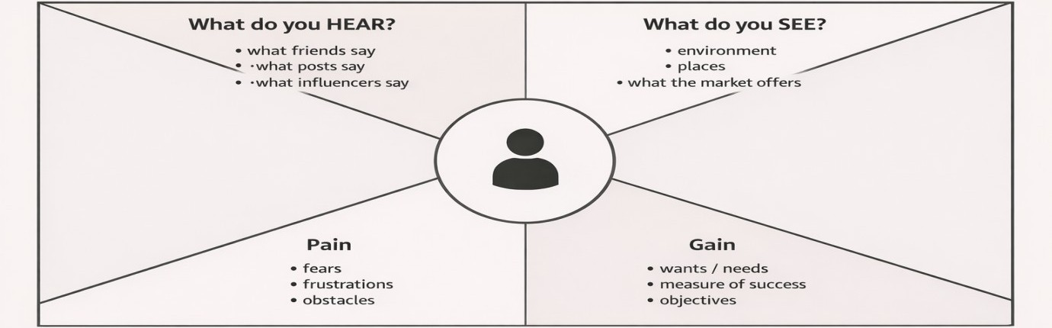
Emotionally, they feel excited about travel but also overwhelmed and uncertain due to too many options and lack of clear guidance. Their main pain points include scattered information, generic itineraries, and time-consuming planning. They want personalized recommendations, efficient planning, and confidence in their decisions. Options, and look for solutions that match their preferences, budget, and time. Their main challenges include time-consuming research, confusion from too much information, and fear of missing the best experiences. Their goal is to have a smooth, enjoyable, and memorable journey with a customized plan that fits their needs. Explore with AI addresses these needs by creating smart, personalized itineraries that simplify travel planning and help travelers confidently explore the world.

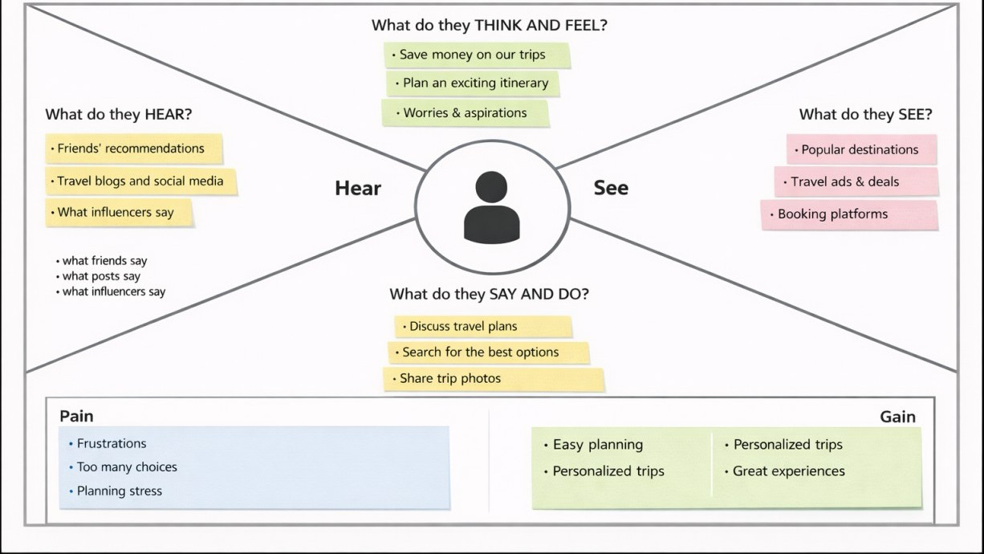
Explore with AI addresses these needs by using intelligent personalization to create customized itineraries based on individual preferences, helping travelers discover relevant destinations and enjoy a smooth, stress-free planning experience..

